**5. ReactJS – HOL**

**Objectives**

* **Understanding the need for styling react component**

React apps often contain reusablecomponents, and just like HTML pages, they need styles for better visual design, usability, and user experience.

Styling in React helps:

1. Improve readability and presentation of data (like your cohort cards).
2. Support responsivelayout (mobile/desktop).
3. Make components modular and reusable with scoped styles.

* **Working with CSS Module and inline styles**

| **Method** | **Description** | **Scope** |
| --- | --- | --- |
| **External CSS** | Traditional .css file imported globally (like App.css) | Global |
| **CSS Modules** | Scoped to the component. Filename ends with .module.css. | Component |
| **Inline Styles** | Styles written directly in the component using JS objects | Element |
| **Styled-Components** | Uses tagged template literals (with styled-components library) | Component |

**EXERCISE – 2:** Styling the React Application

Step 1: Unzip the react application and open the folder in **VS Code**Step 2: Restore the node packages using **npm install**

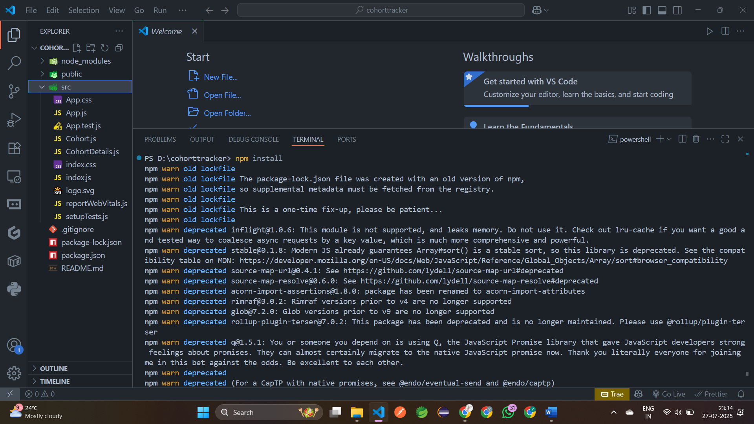

Step 3: Create a new CSS Module in a file called “**CohortDetails.module.css**”  
Step 4: Define a css class with the name as “**box**” with following properties

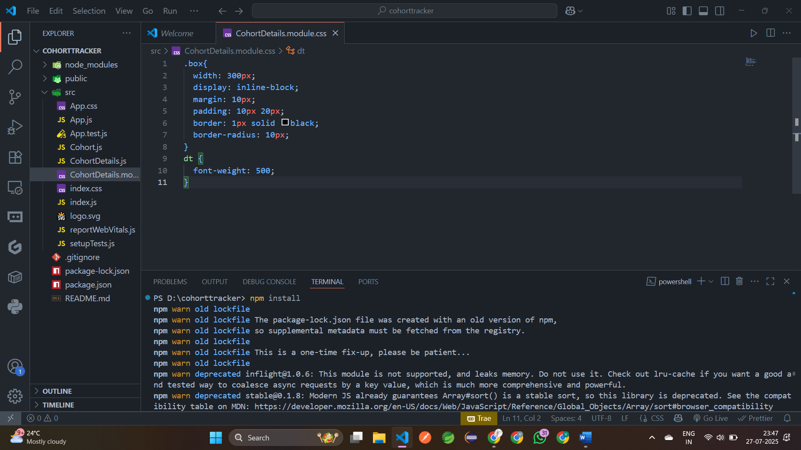

Step 5: Inside Open the **cohort details** component and import the CSS Module

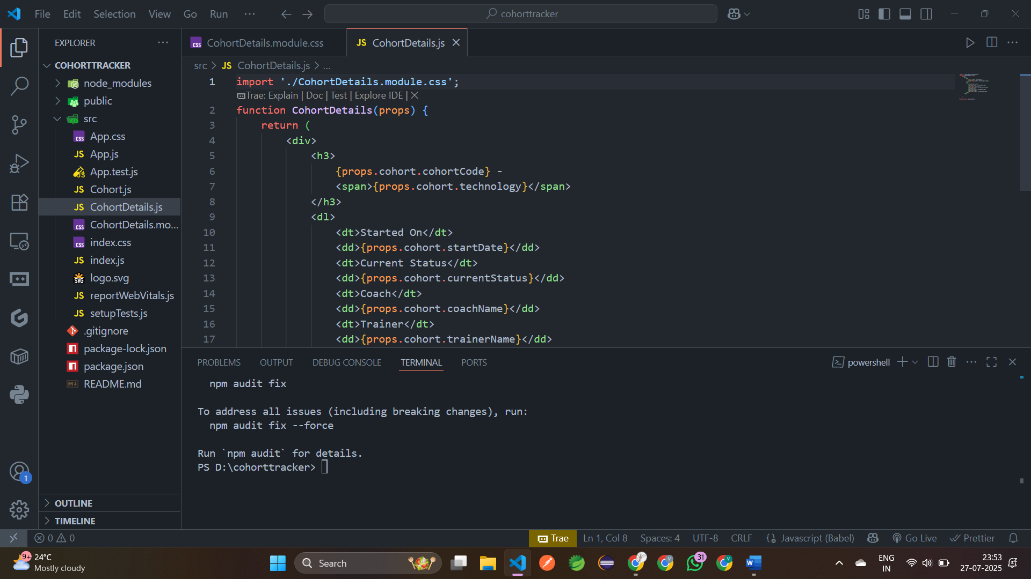

Step 6: Apply the **box class** to the container div  
  
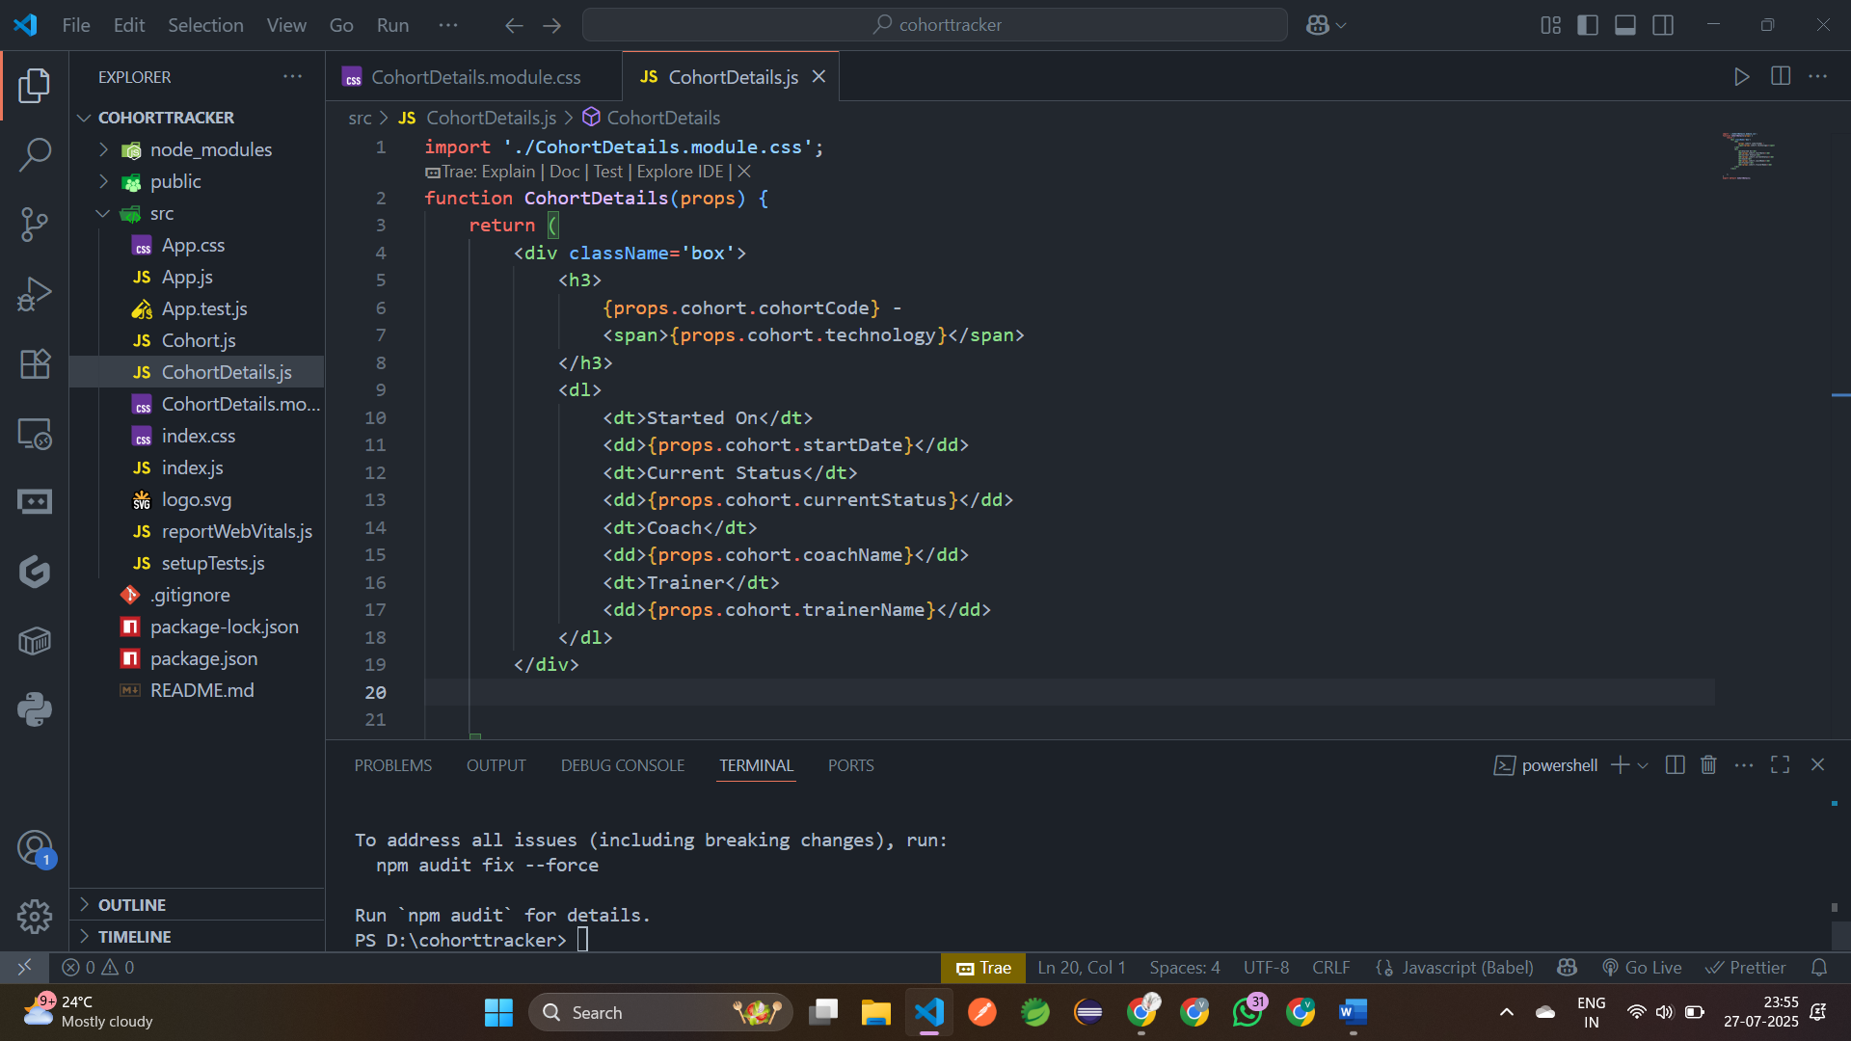

Step 7: Define the style for <h3> element to use “**green**” color font when cohort status is “**ongoing**” and “blue” color in all other scenarios.

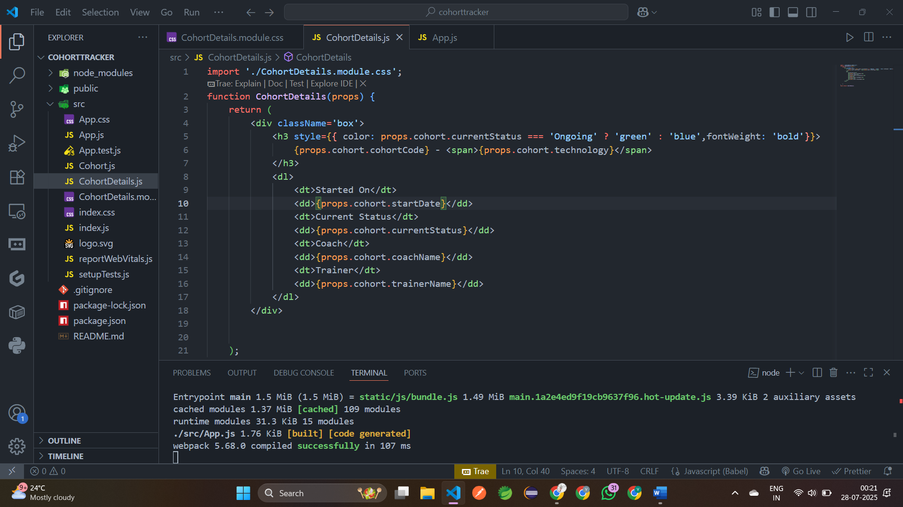  
  
Step 8: Build and Run the application using **npm start** command.

URL: <http://localhost:3000>

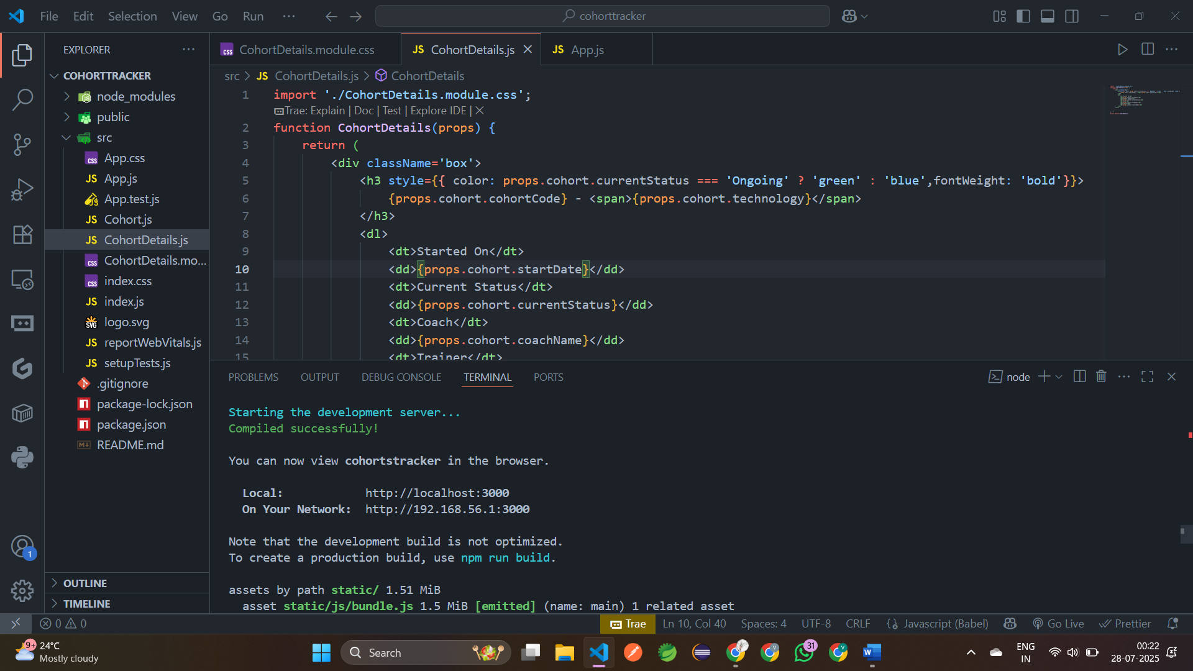

**Output:**

